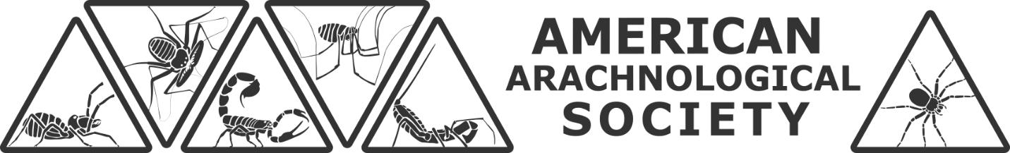

STUDENT RESEARCH GRANT APPLICATION COVER SHEET
Complete this cover sheet and pay careful attention to the checklist details on Page 3.

NAME (Last, First Middle)
<<Edit this text with your name>>

E-MAIL ADDRESS
<<Edit this text with your preferred e-mail address>>

ACADEMIC INSTITUTION (including country)
<<Edit this text with your academic institution and country>>

PROPOSED PROJECT TITLE (Short, descriptive - used for announcements)
<<Edit this text with your project title>>

AMOUNT OF FUNDING REQUESTED (USD $)
<<Edit this text with your funding request (not to exceed 1000 USD $)>>

PREVIOUS APPLICATIONS AND AWARDS
<<If you have previously received funding from the AAS, please provide the award year(s), title(s) of project(s), and amount(s) awarded. A progress report on the project(s) will be required for this application to be considered. If you have previously applied for funding but were not awarded a grant, please provide the year(s) and title(s) of the project(s). If this is your first application for AAS funding, please indicate as such.>>

CURRENT STUDENT STATUS (please check the box that best describes your status)

☐ Undergraduate Student ☐ Master’s Student

☐ Doctoral Student (pre-qualifier) ☐ Doctoral Candidate (post-qualifier)

AAS MEMBERSHIP STATUS (applicants must be student members and dues must be paid by the proposal submission deadline of February 15, 2026)

☐ I am a student member of the American Arachnological Society.

☐ I am not a current student member but am requesting a waiver or sponsored membership. (Sponsored memberships are available only to students from developing countries. All requests for waivers or sponsored memberships must be submitted to the Membership Secretary membership@americanarachnology.org).

I AM APPLYING FOR THE:

☐ AAS Research Fund (ARF) ☐ Vincent Roth Fund for Research in Systematics (VRF)

Deadline: February 15, 2026 — Submit: researchgrants@americanarachnology.org
Please Note:

ARF vs. VRF submissions:
- Applicants may not submit the same proposal to both funds (ARF and VRF).
- Applicants may submit two substantially different proposals in the same grant cycle (one to ARF and one to VRF).
- If a proposal could reasonably fit either fund, the committee may reassign it to the competition in which it has the best chance for funding.
- If two separate proposals are submitted, only one may be funded.

Previously funded projects:
- Applicants may not submit a proposal for a project that has already received AAS funding.
- Each project may be funded only once, but an applicant may be funded more than once for different projects.

Applicant submission requirement:
- Proposals must be submitted by the applicant.
- Proposals submitted on behalf of a student by another person will not be considered.

Duplicate submissions across societies:
- Applicants may not submit proposals for the same project to both the AAS Student Research Grant Fund and the International Society of Arachnology Oscar and Jan Francke Student Research Fund in the same year.
- Substantially similar proposals submitted to both societies in a given year will be declined.
- Substantially different proposals are allowed.

APPLICATION CHECKLIST

Please assemble your application as a SINGLE PDF document in the following order (incomplete applications will not be considered for funding):

☐ COVER SHEET: include only page 1 of this document (cover sheet only). Do not include pages 2–3.

☐ PROGRESS REPORT: Applicants that have received funding during previous grant cycles must submit a report detailing the status of their project.

☐ LETTER OF SUPPORT: Applicants must request a letter of support from a mentor or advisor familiar with their work. The advisor does not need to be a member of the AAS but should be familiar with the applicant and the proposed project. The letter should be dated accordingly, confirm student status, the student’s ability to conduct the study, and demonstrate a need for funding. PLEASE NOTE THAT LETTERS WILL NO LONGER BE SUBMITTED SEPARATELY; THEY MUST BE INCLUDED AS PART OF THE APPLICATION FILE.

☐ PROJECT PROPOSAL

☐ Format: The proposal must be written in English, double-spaced, 11 pt or larger font, 2 cm or larger margins, and not longer than 6 pages (not including references and figures).

☐ Content: The proposal should include the following parts (as appropriate):

- PROJECT TITLE

- NARRATIVE including background information, justification for the proposed study, and the hypothesis to be tested (if applicable).

- METHODS including materials, experimental design, and analyses to be used.

- LITERATURE CITED

- ITEMIZED BUDGET showing in detail how award money would be used in the proposed research.

☐ File Name: The application packet should be assembled as a single PDF using the following file naming format: LastName_ARF_2026.pdf or LastName_VRF_2026.pdf

Application Deadline is February 15, 2026

Applications should be submitted as a SINGLE PDF document to:
Dr. Matthew R. Graham (researchgrants@americanarachnology.org)

